**Installation Guidelines for the softwares that I used**

1. **MongoDB**

**Step 1 — Download the MongoDB MSI Installer Package**

Head over <https://www.mongodb.com/try/download/community>  and download the current version of MongoDB. Make sure you **select MSI**as the package you want to download.

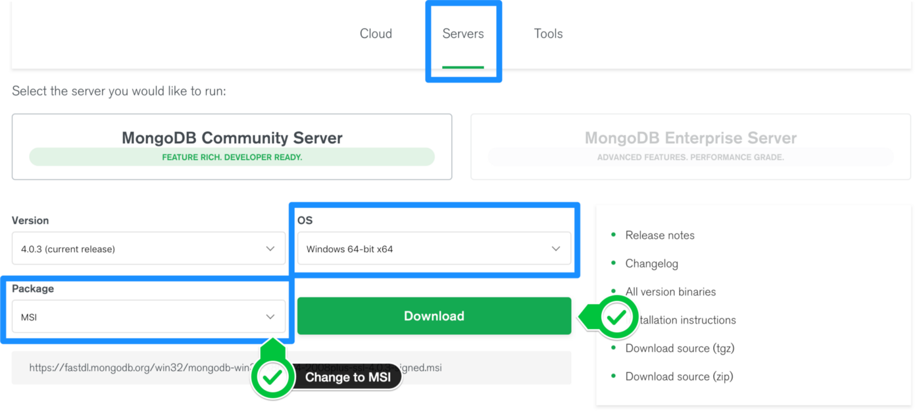

**Step 2 — Install MongoDB with the Installation Wizard**

A. Make sure you are logged in as a user with Admin privileges. Then navigate to your downloads folder and double click on the .msi package you just downloaded. This will launch the installation wizard.

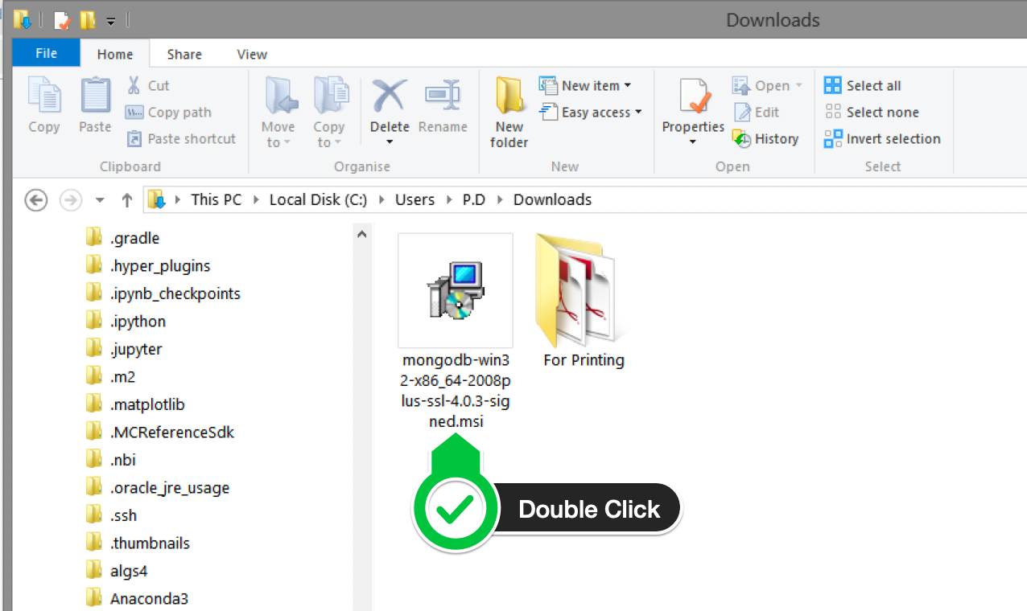

B. Click Next to start installation.

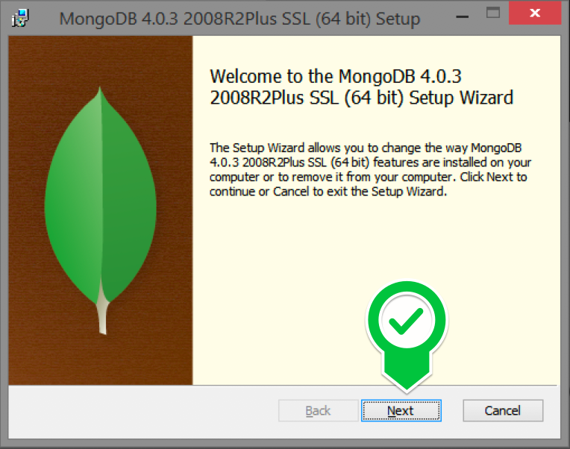

C. Accept the licence agreement then click Next.

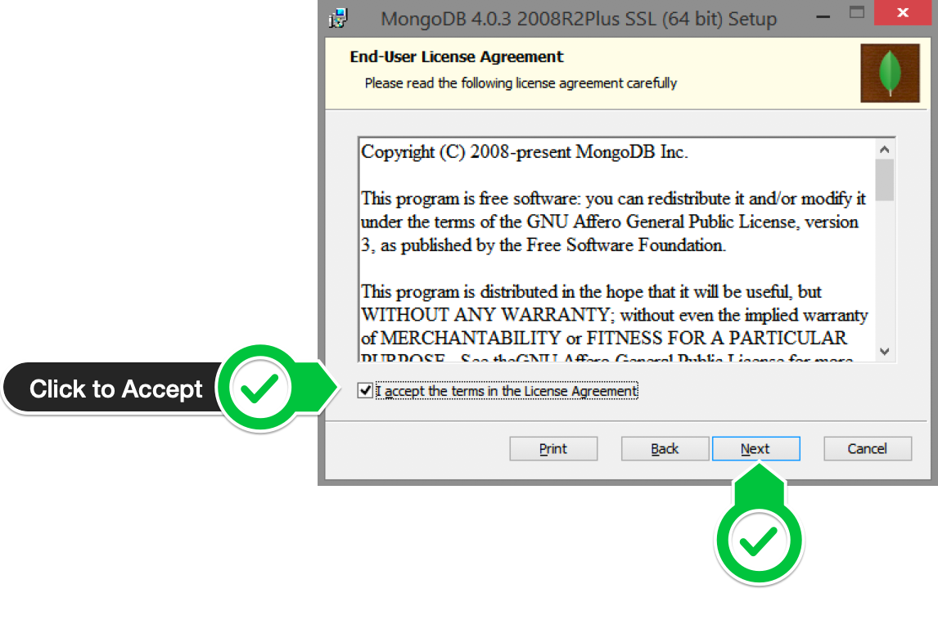

D. Select the Complete setup.

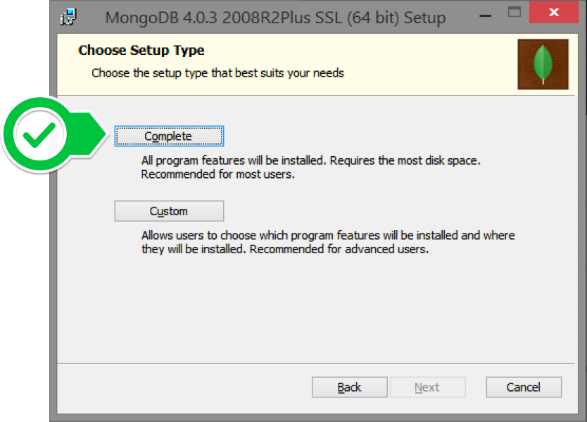

E. Select “Run service as Network Service user” and make a note of the data directory, we’ll need this later.

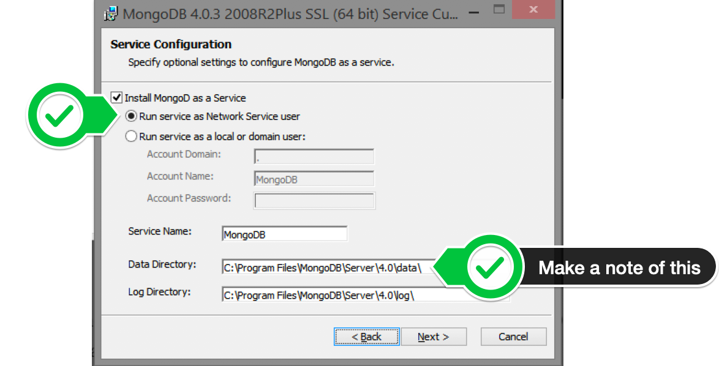

F. We may need Mongo Compass, so select it and click Next.

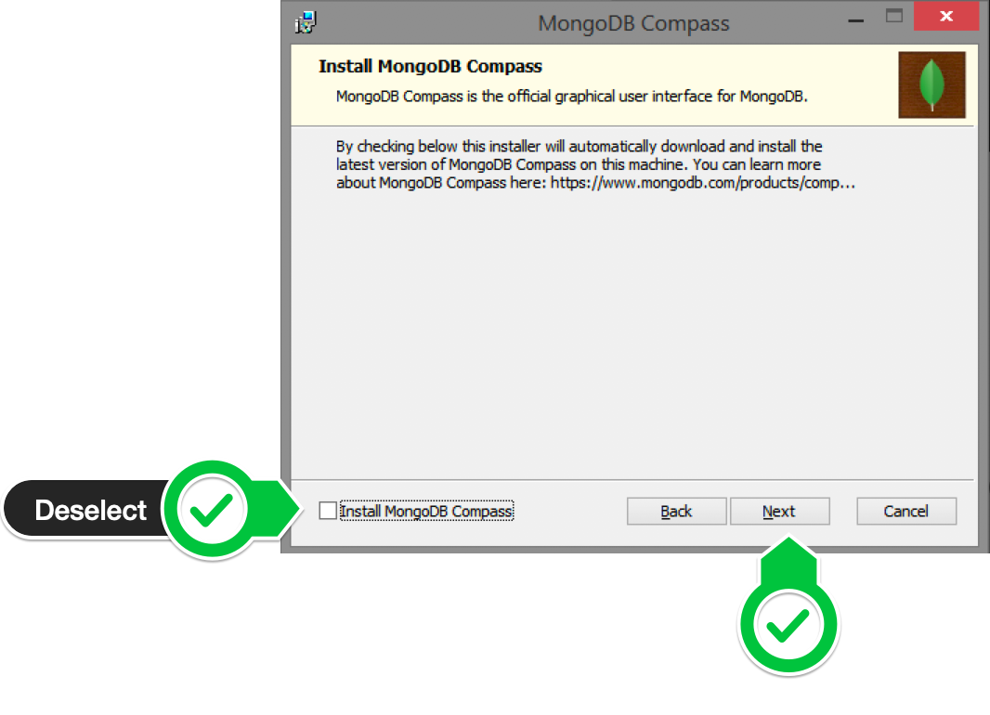

G. Click Install to begin installation.

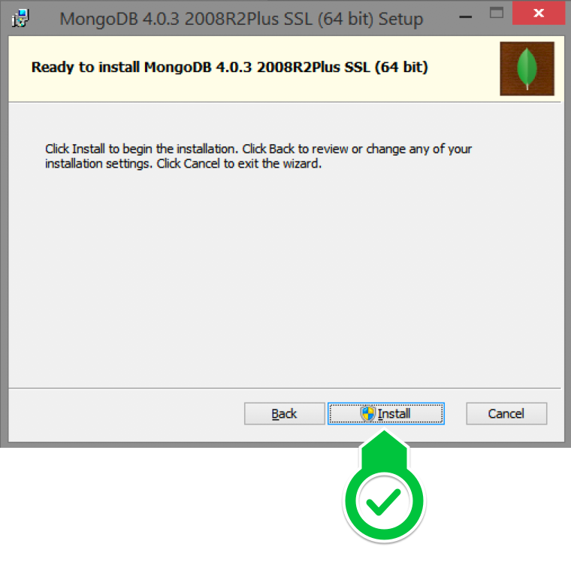

F. Hit Finish to complete installation.

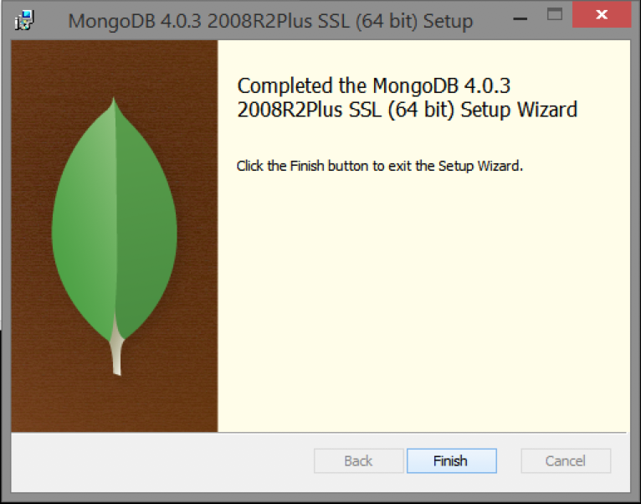

**Step 3— Create the Data Folders to Store our Databases**

A. Navigate to the **C Drive** on your computer using Explorer and create a new folder called **data** here.

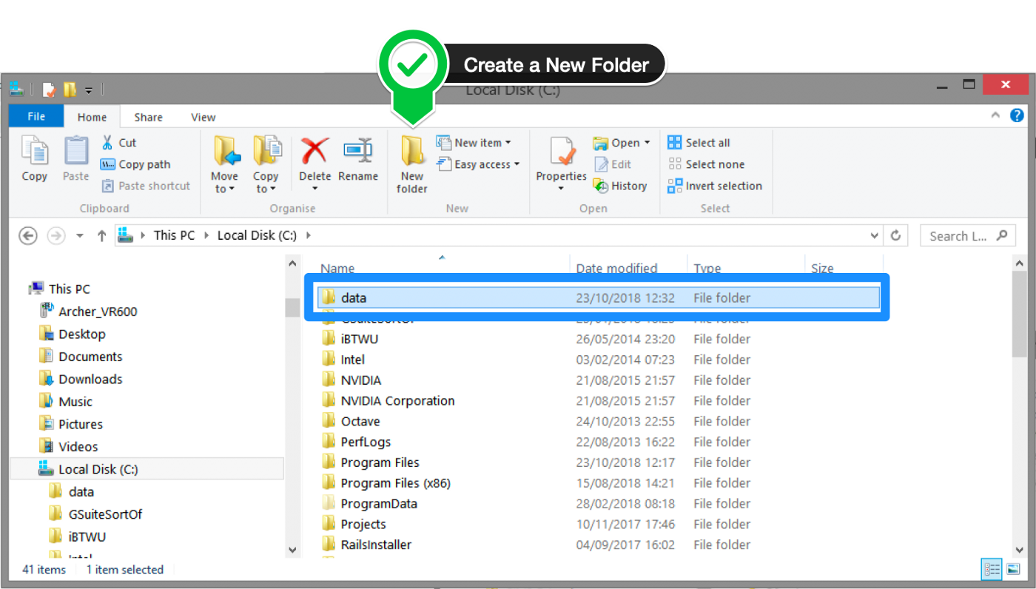

B. Inside the **data** folder you just created, create another folder called **db**.

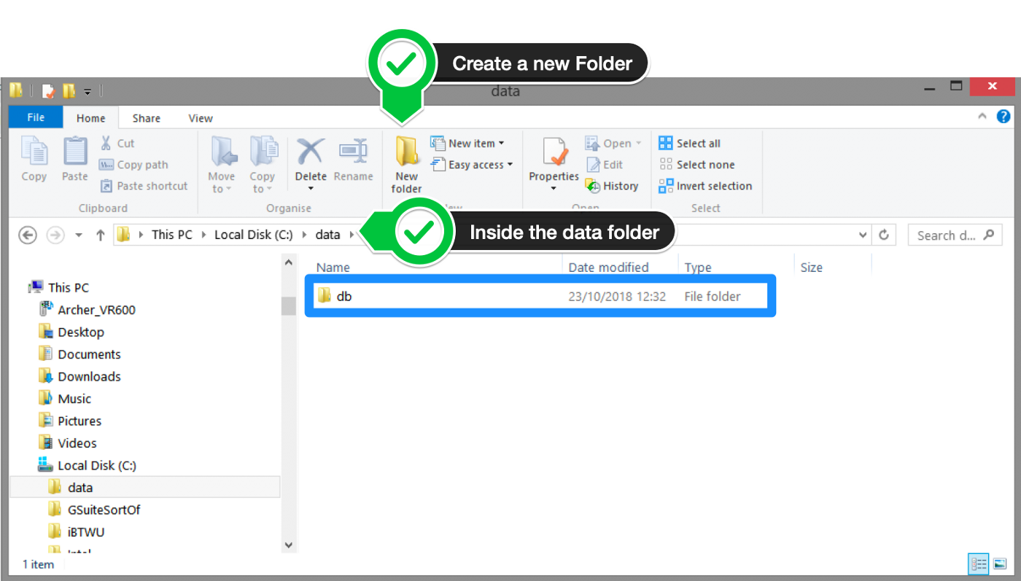

**Step 4 — Setup Alias Shortcuts for Mongo and Mongod**

Once installation is complete, we’ll need to set up MongoDB on the local system.

A. Open up your Hyper terminal running Git Bash.

B. Change directory to your home directory with the following command:

cd ~

C. Here, we’re going to create a file called .bash\_profile using the following command:

touch .bash\_profile

D. Open the newly created .bash\_profile with vim using the following command:

vim .bash\_profile

E. In vim, hit the **I** key on the keyboard to enter insert mode.

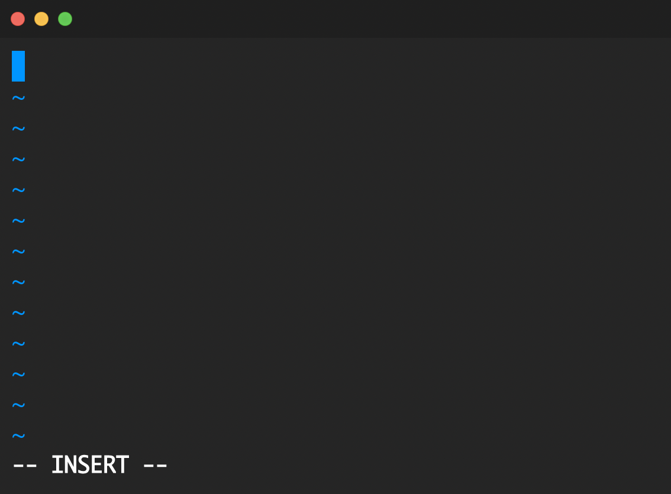

F. In your explorer go to C → Program Files → MongoDB → Server

Now you should see the version of your MongoDB.

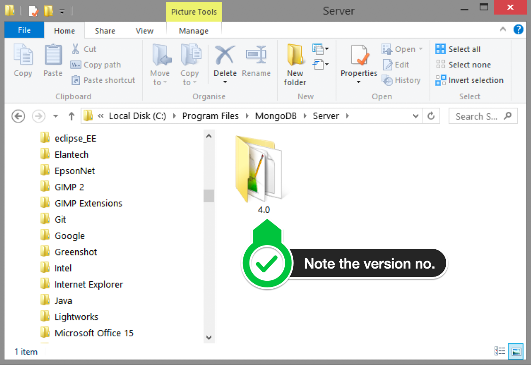

G. Paste in the following code into vim, make sure your replace the 4.0 with your version that you see in explorer

alias mongod="/c/Program\ files/MongoDB/Server/4.0/bin/mongod.exe"  
alias mongo="/c/Program\ Files/MongoDB/Server/4.0/bin/mongo.exe"

F. Hit the Escape key on your keyboard to exit the insert mode. Then type

:wq!

to save and exit Vim.

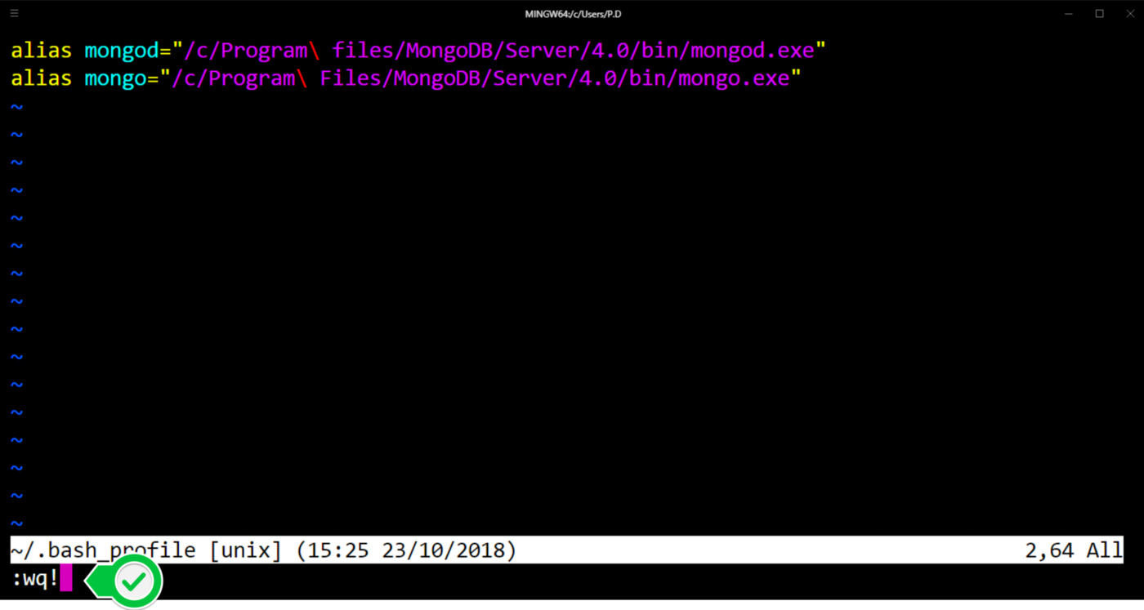

**Step 5 — Verify That Setup was Successful**

A. Close down the current Hyper terminal and quit the application.

B. Re-launch Hyper.

C. Type the following commands into the Hyper terminal:

mongo --version

Once you’ve hit enter, you should see something like this:

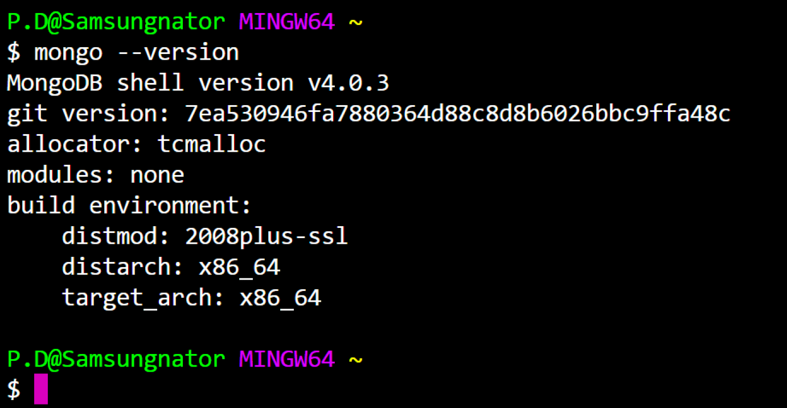

This means that you have successfully installed and setup MongoDB on your local system!

If you see something that looks like bash mongo command not found, then make sure you check back at all the steps above and follow it step-by-step making sure there are no typos and you haven’t missed any of the steps.

**Postman Installation:**

### Steps to download and install the native Postman application

**Step-1:** Go to the link <https://www.postman.com/downloads/> and click download for Mac or Windows or Linux based on your operating system.

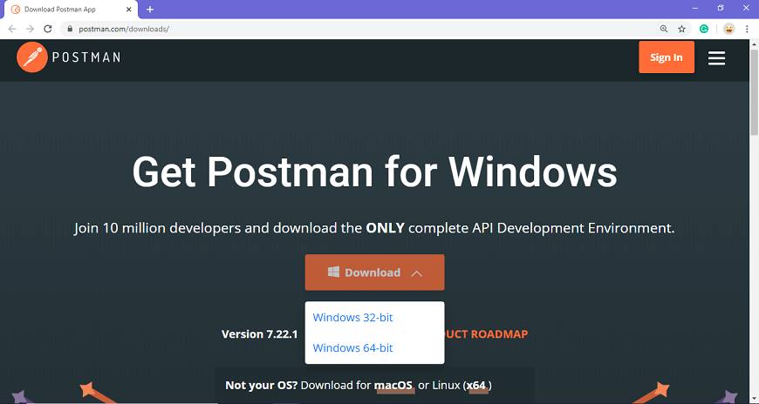

**Step-2:** For downloading the app for Windows, click on the download button and select the particular version. I opted for the 64-bit version. If you are using a 32-bit OS, you can choose the 32 bit, as shown in the above image.

**Step-3:** You can check the download progress on the bottom left if you are using the Chrome browser. Once the .exe file is downloaded, you need to install the application, as shown in the below image.

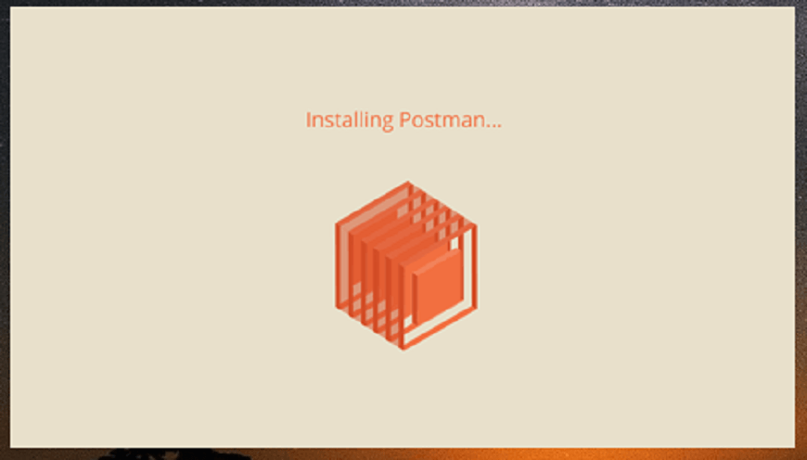

**Step-4:** Once the installation completes, you will be redirected to a window as shown in the image where you can click on **Stop signing in and take me straight to the app** (as this app can also be used without logging in) or otherwise you will get a new window to sign up.

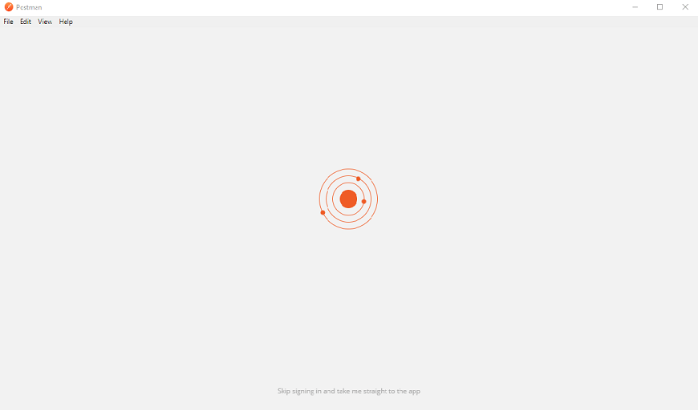

It is better to create an account as this will help you to save the work you do within the Postman, and with this, you won't lose any work.

**Step-5:** Create your account with all the required details, or you can also signup with Google, as shown in the image.

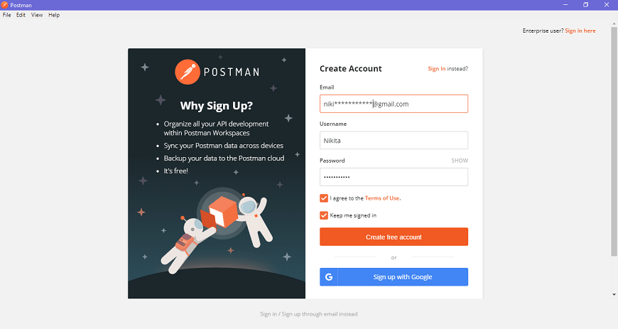

**Step-6:** After signing in, select the workspace tools as per your requirement, and then click on, continue to get the startup screen.

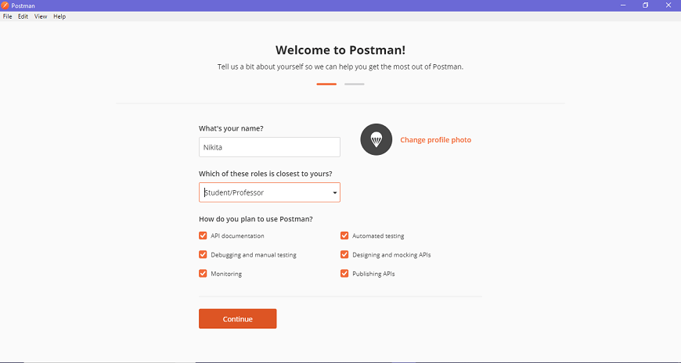

**Step-7:** You will see the following page, and then you are ready to use Postman.

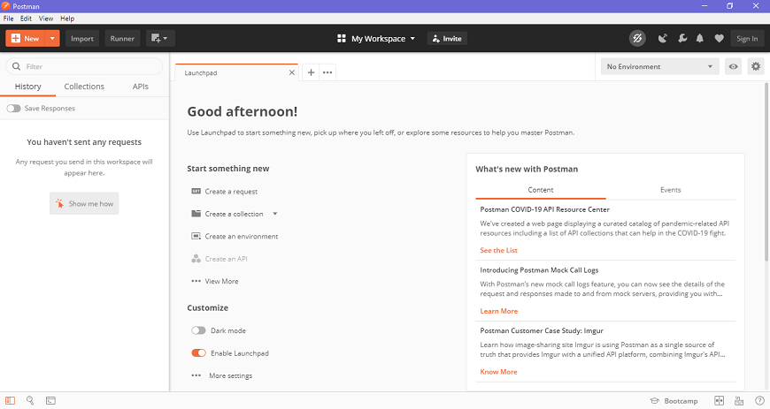

### Steps to update the Postman

* You will receive a notification in your Postman app if any update is available.
* To download or install the latest update, click on the **Settings icon,** as shown in the image below, go to **Settings>Update**.  
  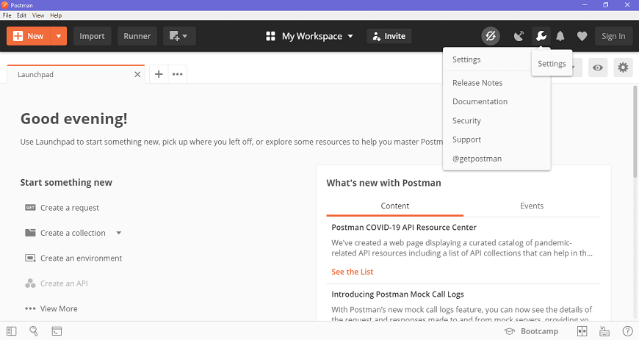
* You can change the update settings by enabling the settings of **automatically download major updates**, as shown in the image below.  
  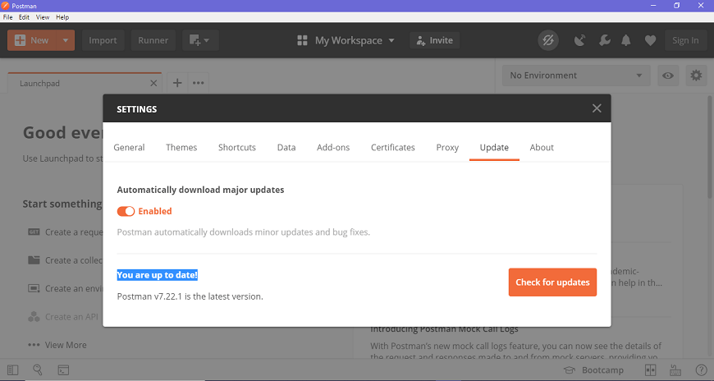
* You can also check for the latest updates by clicking on **Check for updates**, which will show you if any new update is available.
* You will have to select the update option to download and install the latest update. When the download is complete, you will see a notification asking you to restart the app to install the updated features.
* It automatically downloads minor updates and bug fixes.

**Node.Js Installation**

**Installing Node js:**

You have to follow the following steps to install the Node.js on your Windows :

**Step-1:** Downloading the Node.js ‘.msi’ installer.

The first step to install Node.js on windows is to download the installer. Visit the official Node.js website i.e) <https://nodejs.org/en/download/> and download the .msi file according to your system environment (32-bit & 64-bit). An MSI installer will be downloaded on your system.

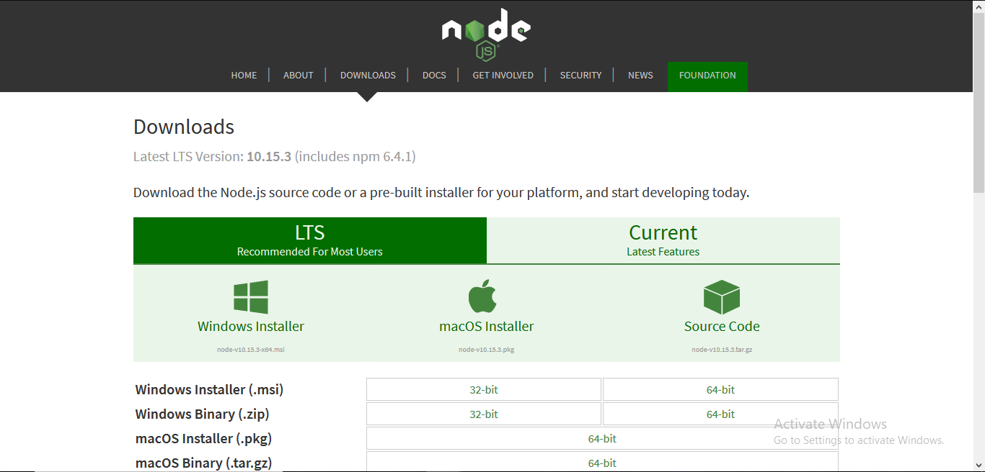

**Step-2:** Running the Node.js installer.

Now you need to install the node.js installer on your PC. You need to follow the following steps for the Node.js to be installed:-

* Double click on the .msi installer.

***The Node.js Setup wizard will open.***

* Welcome To Node.js Setup Wizard.

***Select “Next”***

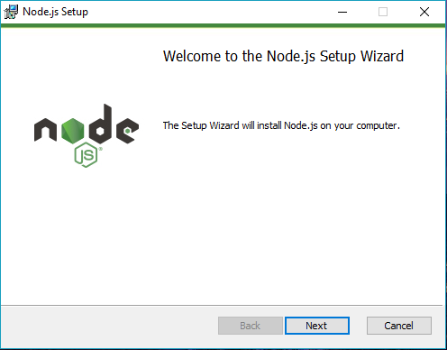

* After clicking “Next”, End-User License Agreement (EULA) will open.

***Check “I accept the terms in the License Agreement”***

***Select “Next”***

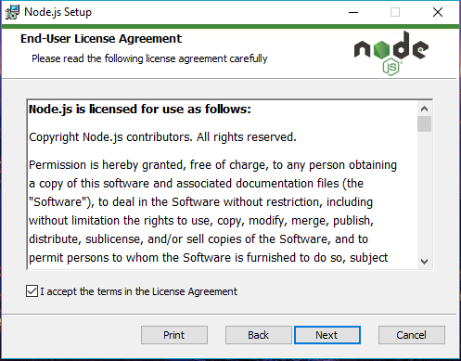

* Destination Folder

***Set the Destination Folder where you want to install Node.js & Select “Next”***

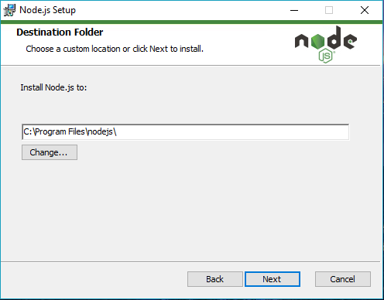

* Custom Setup

***Select “Next”***

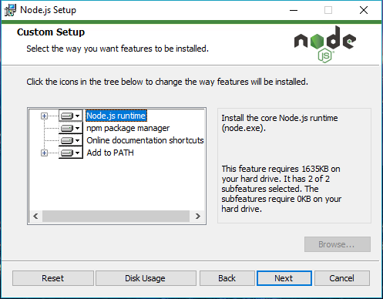

* Ready to Install Node.js.

***Select “Install”***

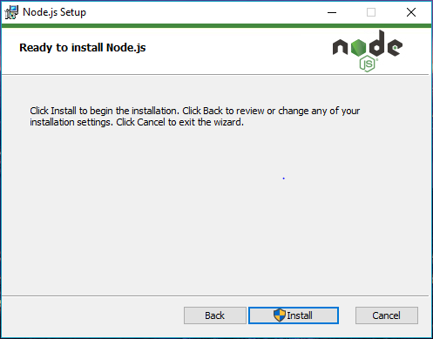

**NOTE :**

A prompt saying – “This step requires administrative privileges” will appear.

Authenticate the prompt as an **“Administrator”**

* Installing Node.js.

Do not close or cancel the installer until the install is complete

* Complete the Node.js Setup Wizard.

***Click “Finish”***

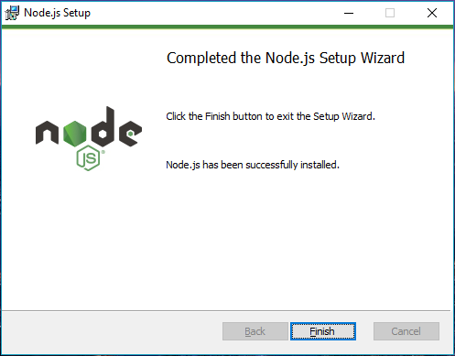

**Step 3: Verify that Node.js was properly installed or not.**

To check that node.js was completely installed on your system or not, you can run the following command in your command prompt or Windows Powershell and test it:-

***C:\Users\Admin> node -v***

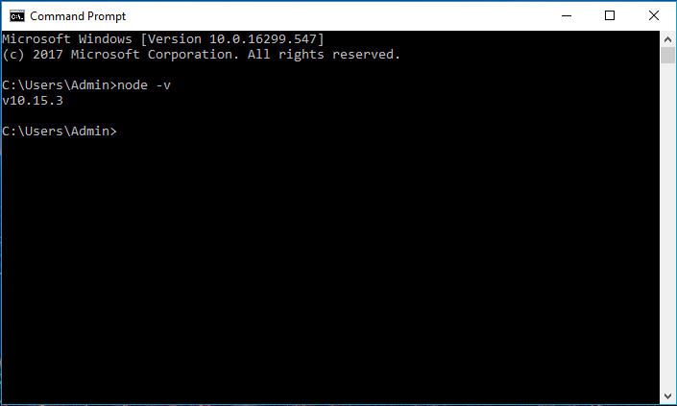

If node.js was completely installed on your system, the command prompt will print the version of the node.js installed.

**Step 4: Updating the Local npm version.**

The final step in node.js installed is the updation of your local npm version(if required) – the package manager that comes bundled with Node.js.

### ****Installation Reactjs on Windows:****

**Step 1**: Install Node.js installer for windows. Click on this <https://nodejs.org/en/>. Here install the LTS version (the one present on the left). Once downloaded open NodeJS without disturbing other settings, click on the **Next**button until it’s completely installed.

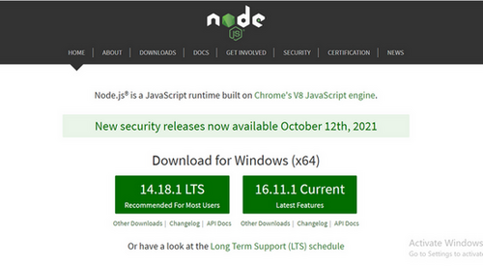

*Install the 14.18.1 LTS*

**Step 2**: Open command prompt  to check whether it is completely installed or not type the command –>

node -v

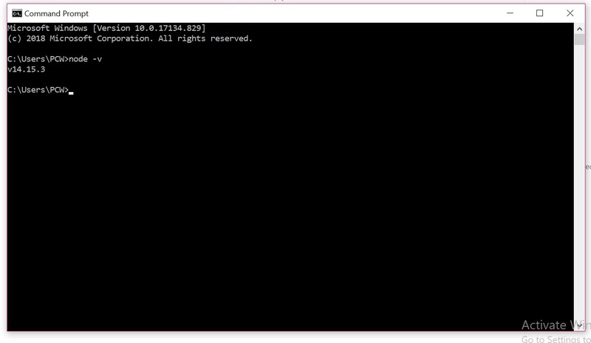

*Node Version is v14.15.3*

If the installation went well it will give you the version you have installed

**Step 3**: Now in the terminal run the below command:

npm install -g create-react-app

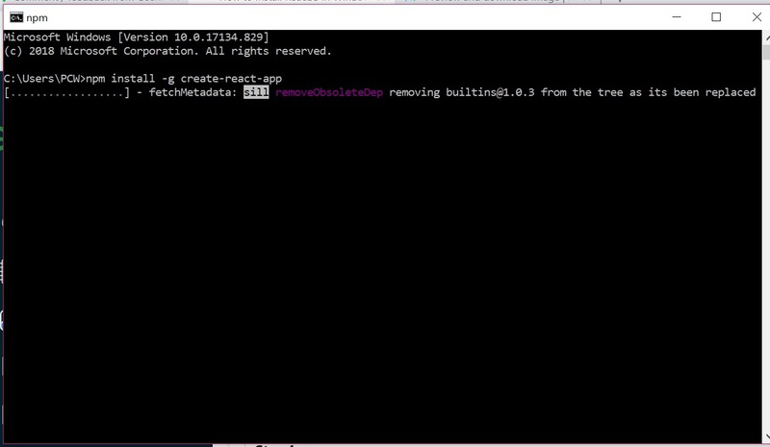

*Installation will take few seconds*

It will globally install react app for you. To check everything  went well run the command

create-react-app --version

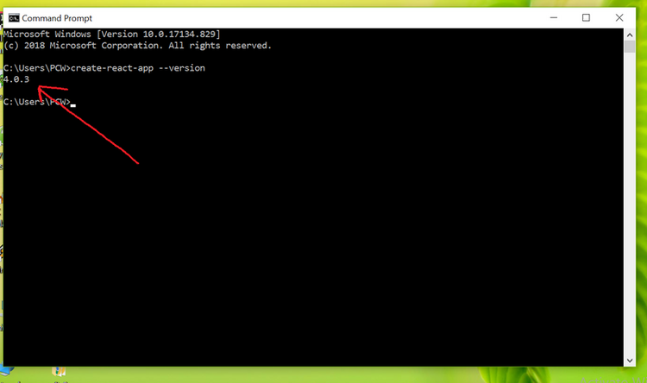

*version  4.0.3*

If everything went well it will give you the installed version of react app

**Step 4:**Now Create a new folder where you want to make your react app using the below command:

mkdir newfolder

**Note:** The *newfolder*in the above command is the name of the folder and can be anything.

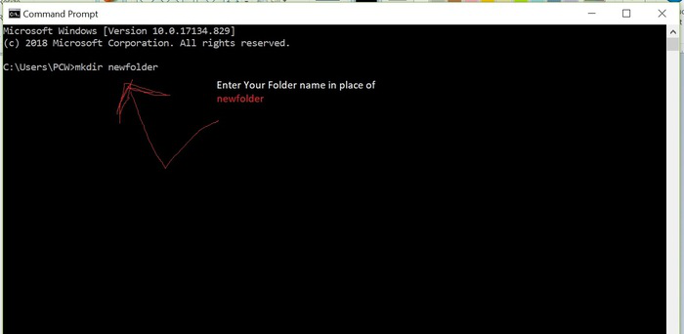

Move inside the same folder using the below command:

cd newfolder (your folder name)

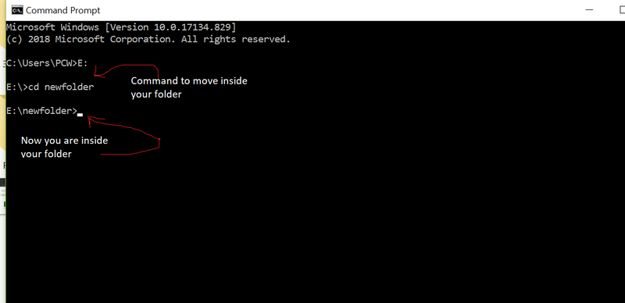

**Step 5**: Now inside this folder run the command –>

create -react -app reactfirst YOUR\_APP\_NAME

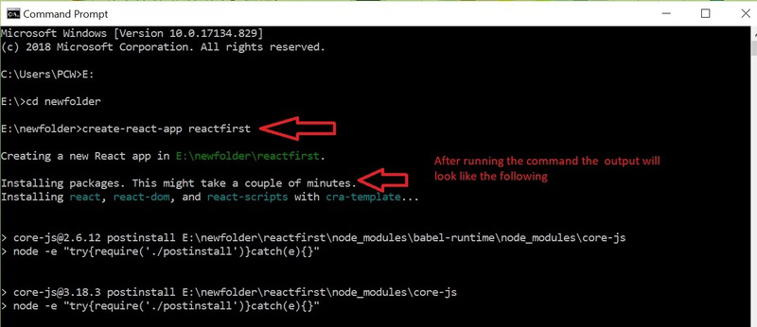

It will take some time to install the required dependencies

**Step 6**: Now open the IDE of your choice for eg.  Visual studio code and open the folder where you have installed the react app **newolder**(in the above example)  inside the folder you will see your app’s name **reactapp**(In our example). Use the terminal and move inside your app name folder.Use command  **cd reactapp**(your app name)

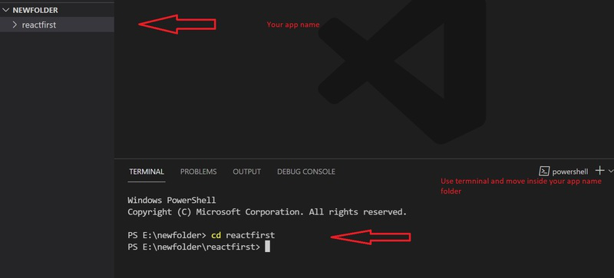

**Step 7:**To start your app run the below command :

npm start

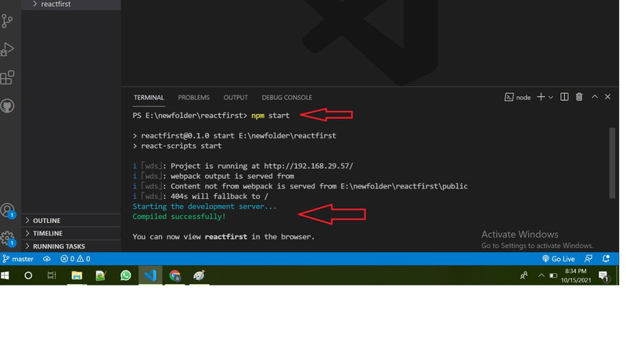

Once you run the above command a new tab will open in your browser showing React logo as shown below :

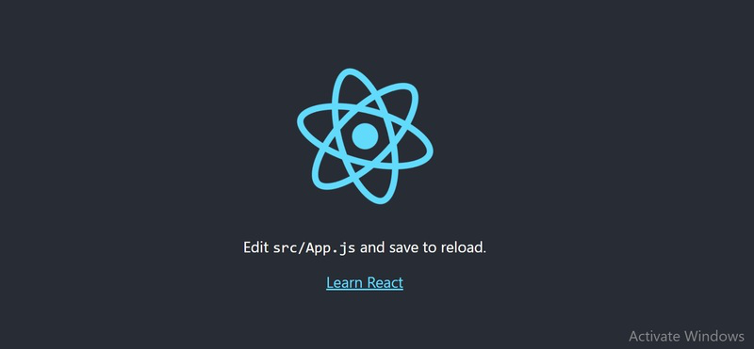

Congratulation you have successfully installed the react-app and are ready to build awesome websites and app

VS Code Installation

***Download the executable file from https://code.visualstudio.com/download.***

## [Visual Studio Code - Code Editing. Redefined](https://code.visualstudio.com/" \t "_blank)

### [Visual Studio Code is a code editor redefined and optimized for building and debugging modern web and cloud…](https://code.visualstudio.com/" \t "_blank)

[code.visualstudio.com](https://code.visualstudio.com/" \t "_blank)

***Click the option Download.***

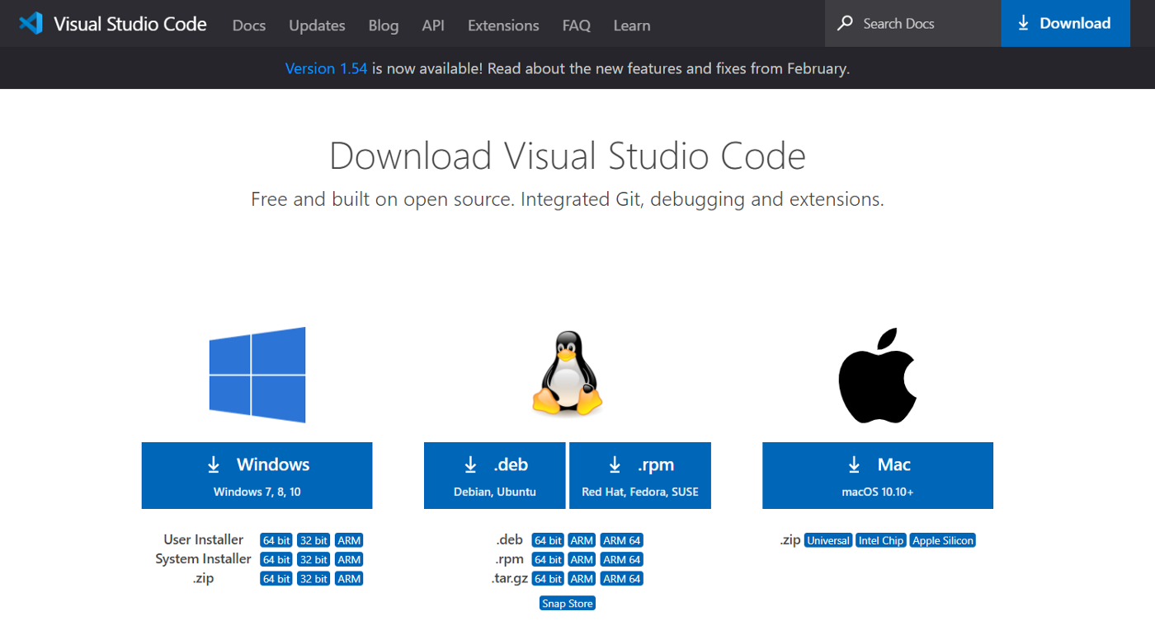

***Double click the downloaded file.***

***Now a dialogue box appears.***

***Select I accept the agreement***

***Then select Next***

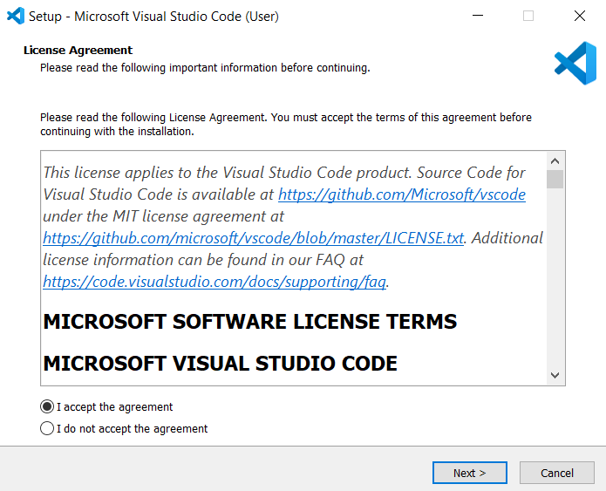

***Select a folder by clicking Browse or just follow the default path.***

***Then select Next.***

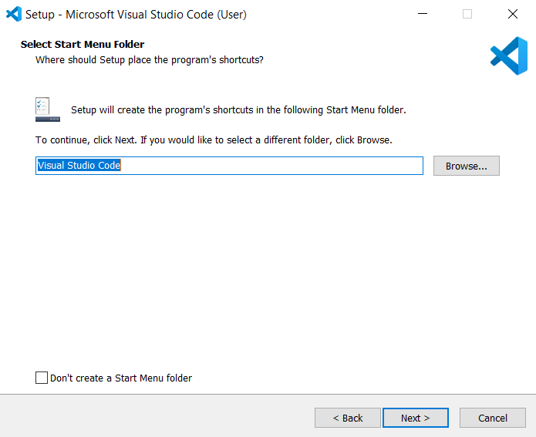

***Select the required options as per your need by clicking in the checkbox.***

***Then select Next.***

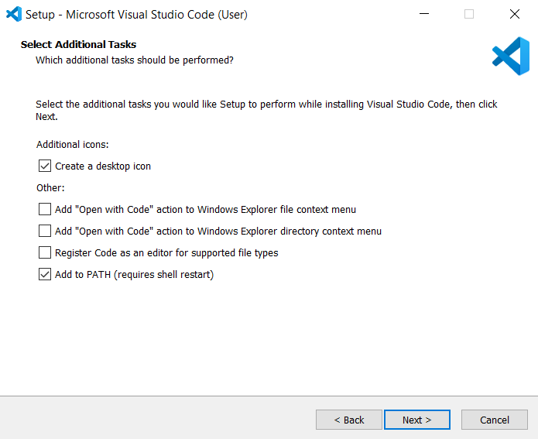

***Select Install.***

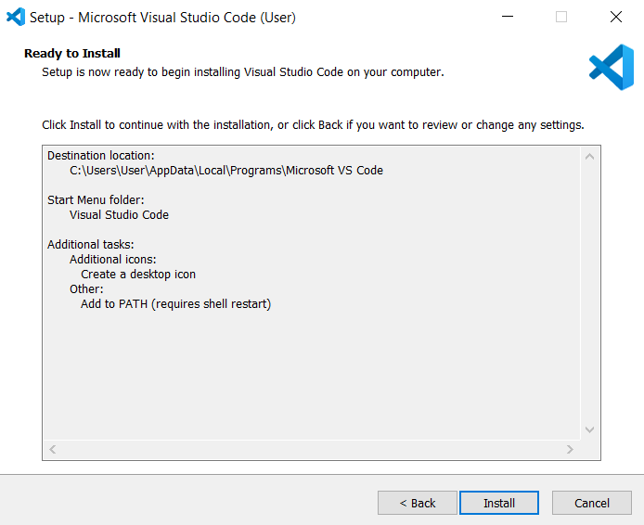

***Wait a bit while it gets installed (The green color fills the bar).***

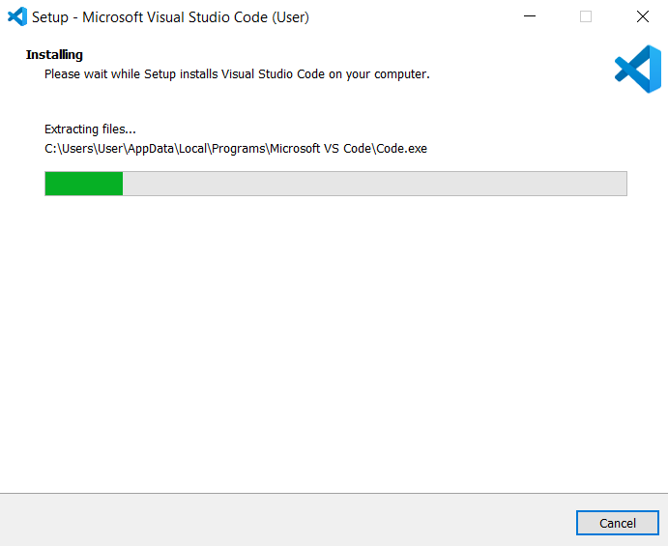

***Click Finish to exit Setup. Check in the check box to launch VS Code right now.***

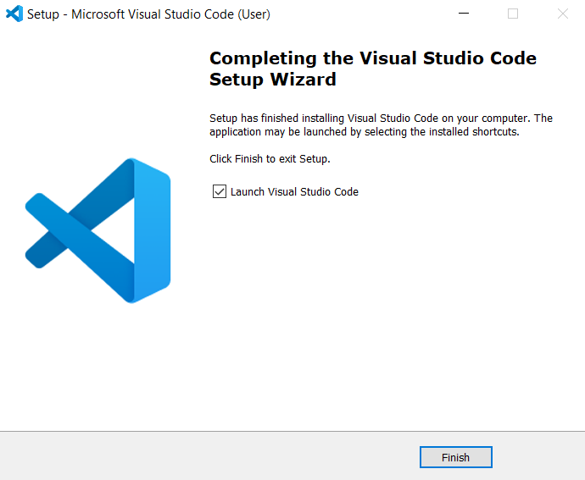

***Congratulation! VS Code got installed in your system successfully.***

***Now a new dialogue box appears. This is VS Code IDE.***

***Click New file to open a new file.***

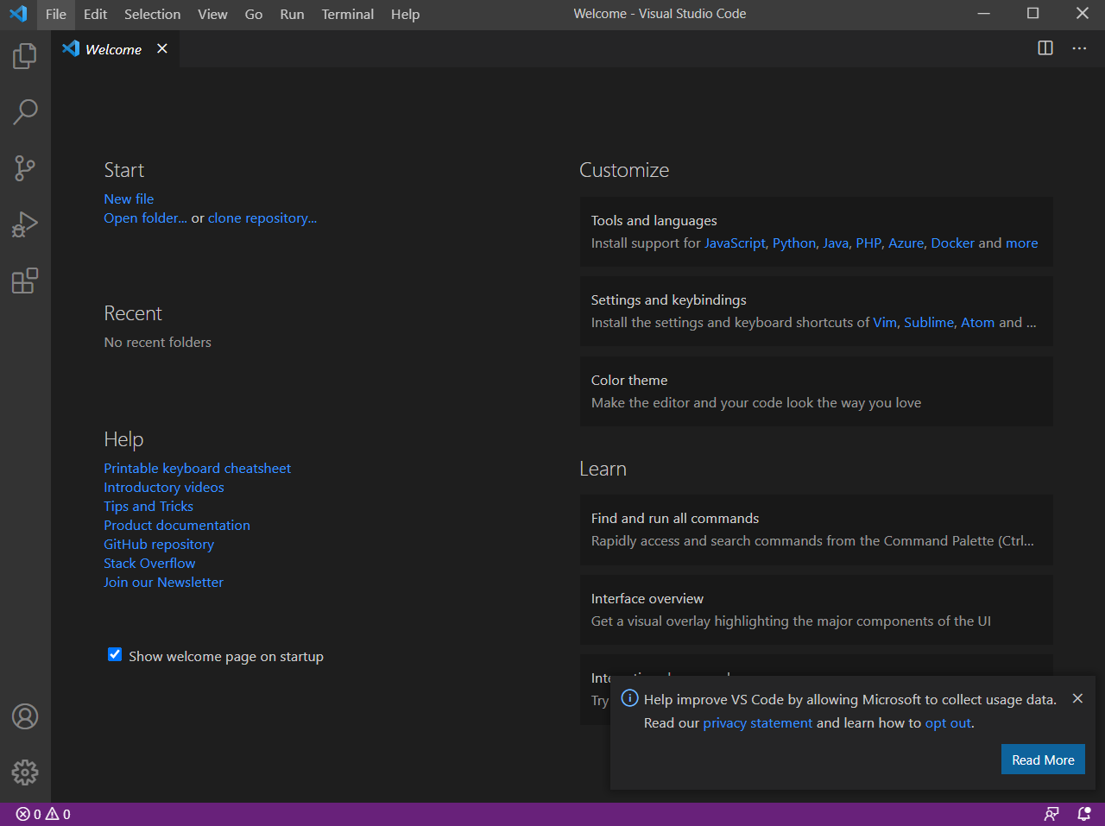

***All done!***

